This data set is created by recording the transactions made. These shopping carts were randomly generated. This data set contains 3 columns: “Date to add register”, “Id transaction”, “Product for id transaction”.

In total are 38 products considered in this research:

Yogurt Pork Sandwich bags Lunch-Meat

All- purpose Flour Soda Butter

Vegetables Beef Aluminum Foil Dinner rolls

Shampoo Mixes Soap Laundry detergent

Ice cream Toilet paper Waffles Cheeses

Milk Individual meals Hand soap Dishwashing

Poultry Cereals Milk Ketchup

Spaghetti sauce Eggs Juice Pasta

Tortillas Fruit Coffee/Tea Bagels

Sugar Paper towels

Just from a preliminary overview, we can say that vegetables represent 8% of all purchases, poultry 3% and the rest is contained in the remaining 89%

We start with some simple statistics on data to understand the frequency of purchases. On the left we have the histogram of item frequency in absolute terms and in the right one in relative terms. As we can see vegetables have the frequency that is more that twice

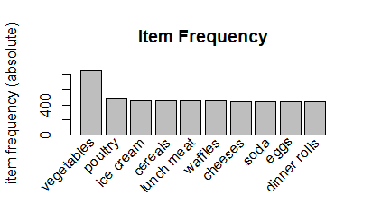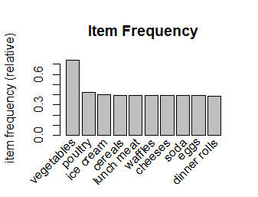

Another statistic test we can apply to this data to gain more information about the relation between them is chi-squared. This test measures the relations of data and the significativity level.

We first created a cross table between data and after we applied the chi-squared test as shown in the table below.  
For this test the null hypothesis H0: independent rows and columns

and to reject or accept this hypothesis we have to observe p-value .

From the whole output of R we just chose a small sample just to make it visible for the concept.

> round(chi2tab,3)

vegetables poultry ice cream cereals lunch meat waffles cheeses soda eggs

vegetables NA 0.001 0.000 0.001 0.001 0.002 0.001 0.001 0.005

poultry 0.001 NA 0.001 0.001 0.002 0.000 0.002 0.000 0.001

ice cream 0.000 0.001 NA 0.000 0.002 0.002 0.004 0.001 0.001

cereals 0.001 0.001 0.000 NA 0.001 0.000 0.003 0.000 0.003

lunch meat 0.001 0.002 0.002 0.001 NA 0.005 0.000 0.000 0.000

waffles 0.002 0.000 0.002 0.000 0.005 NA 0.002 0.004 0.002

cheeses 0.001 0.002 0.004 0.003 0.000 0.002 NA 0.002 0.002

soda 0.001 0.000 0.001 0.000 0.000 0.004 0.002 NA 0.008

eggs 0.005 0.001 0.001 0.003 0.000 0.002 0.002 0.008 NA

**Generating Rules**

There are three parameters controlling the number of rules to be generated  **Support and Confidence**. Another parameter **Lift** is generated using Support and Confidence and is one of the major parameters to filter the generated rules.

To generate the rules we have to use the Apriori with a confidence factor of 80% and a support rank of

15%. We can notice from the output that are 22 generated rules from 38 items and 1139 transactions.

Also is shown the minimum support count means the minimum number of appears of the itemset is 170.

‘Minlen’ and ‘Maxlen’ has value 1 like minimum and maximum number of items required in the rule

‘Maxtime’ is 5 and stands for the maximum amount of time allowed to check for subsets

We have ‘originalSupport’ indicator that is “TRUE” because the traditional support value only considers both LHS and RHS items for calculating support.

‘Aval’ is logical indicator whether to return the additional rule evaluation measure selected with ‘arem’ and in our case is “FALSE”.

> rules <- apriori(mba, parameter = list(support = 0.15, confidence = 0.8))

Apriori

Parameter specification:

confidence minval smax arem aval originalSupport maxtime support minlen maxlen target ext

0.8 0.1 1 none FALSE TRUE 5 0.15 1 10 rules FALSE

Algorithmic control:

filter tree heap memopt load sort verbose

0.1 TRUE TRUE FALSE TRUE 2 TRUE

Absolute minimum support count: 170

set item appearances ...[0 item(s)] done [0.00s].

set transactions ...[38 item(s), 1139 transaction(s)] done [0.00s].

sorting and recoding items ... [38 item(s)] done [0.00s].

creating transaction tree ... done [0.00s].

checking subsets of size 1 2 3 done [0.00s].

writing ... [22 rule(s)] done [0.00s].

creating S4 object ... done [0.00s].

**1) Support:** It is calculated to check how much popular a given item is. It is measured by the proportion of transactions in which an itemset appears. For example, there are 100 people who bought something from grocery store today, amoung those 100 people, there are 10 people who bought bananas. Hence, the support of people who bought bananas will be (10/100 = 10%).

A rule with a lift of 1.5 imply that, the items in LHS and RHS (X & Y) are 1.5 times more likely to be purchased together compared to the purchases when they are assumed to be unrelated.  
Lift is symmetric for the relations of X and Y Lift (X->Y)=Lift (Y->X)

> inspect(sort(optimal_value_rules, by="support", decreasing = T))

lhs rhs support confidence lift count

{eggs} => {vegetables} 0.3266023 0.8378378 1.133370 372

{yogurt} => {vegetables} 0.3195786 0.8310502 1.124188 364

{aluminum foil} => {vegetables} 0.3107989 0.8082192 1.093304 354 {laundry detergent} => {vegetables} 0.3090430 0.8167053 1.104783 352

{sugar} => {vegetables} 0.2976295 0.8248175 1.115757 339

{sandwich loaves} => {vegetables} 0.2827041 0.8090452 1.094421 332

{dinner rolls,poultry} => {vegetables} 0.1615452 0.8288288 1.121183 184

{dishwashing liquid/detergent,poultry}=> {vegetables} 0.1597893 0.8544601 1.155855 182

{eggs,soda} => {vegetables} 0.1580334 0.8450704 1.143153 180

{lunch meat,poultry} => {vegetables} 0.1580334 0.8490566 1.148546 180

{eggs,yogurt} => {vegetables} 0.1571554 0.8994975 1.216779 179

{lunch meat,waffles} => {vegetables} 0.1571554 0.8523810 1.153043 179

{mixes,poultry} => {vegetables} 0.1562774 0.8599034 1.163218 178

{dinner rolls,eggs} => {vegetables} 0.1562774 0.8989899 1.216092 178

{eggs,poultry} => {vegetables} 0.1553995 0.8805970 1.191211 177

{dishwashing liquid/detergent,eggs} => {vegetables} 0.1536435 0.8974359 1.213990 175

{aluminum foil,yogurt} => {vegetables} 0.1527656 0.8613861 1.165224 174

{poultry,yogurt} => {vegetables} 0.1527656 0.8446602 1.142599 174

{poultry,sugar} => {vegetables} 0.1518876 0.8480392 1.147169 173

{cereals,laundry detergent} => {vegetables} 0.1510097 0.8911917 1.205543 172

{cereals,eggs} => {vegetables} 0.1510097 0.8643216 1.169195 172

{cheeses,eggs} => {vegetables} 0.1501317 0.8860104 1.198534 171

**2) Confidence:** It is calculated to check how likely if item X is purchased when item Y is purchased. This is measured by the proportion of transactions with item X, in which item Y also appears. Suppose, there are 10 people who bought apple(out of 100), and from those 10 people, 6 people also bought yogurt. Hence, the confidence of (apple -> yogurt) is: (apple -> yogurt) / apple [i.e. 6/10 = 0.6].

> inspect(sort(optimal_value_rules, by="confidence", decreasing = T))

lhs rhs support confidence lift Count

{eggs,yogurt} => {vegetables} 0.1571554 0.8994975 1.216779 179

{dinner rolls,eggs} => {vegetables} 0.1562774 0.8989899 1.216092 178

{dishwashing liquid/detergent,eggs} => {vegetables} 0.1536435 0.8974359 1.213990 175

{cereals,laundry detergent} => {vegetables} 0.1510097 0.8911917 1.205543 172

{cheeses,eggs} => {vegetables} 0.1501317 0.8860104 1.198534 171

{eggs,poultry} => {vegetables} 0.1553995 0.8805970 1.191211 177

{cereals,eggs} => {vegetables} 0.1510097 0.8643216 1.169195 172

{aluminum foil,yogurt} => {vegetables} 0.1527656 0.8613861 1.165224 174

{mixes,poultry} => {vegetables} 0.1562774 0.8599034 1.163218 178

{dishwashing liquid/detergent,poultry} => {vegetables} 0.1597893 0.8544601 1.155855 182

{lunch meat,waffles} => {vegetables} 0.1571554 0.8523810 1.153043 179

{lunch meat,poultry} => {vegetables} 0.1580334 0.8490566 1.148546 180

{poultry,sugar} => {vegetables} 0.1518876 0.8480392 1.147169 173

{eggs,soda} => {vegetables} 0.1580334 0.8450704 1.143153 180

{poultry,yogurt} => {vegetables} 0.1527656 0.8446602 1.142599 174

{eggs} => {vegetables} 0.3266023 0.8378378 1.133370 372

{yogurt} => {vegetables} 0.3195786 0.8310502 1.124188 364

{dinner rolls,poultry} => {vegetables} 0.1615452 0.8288288 1.121183 184

{sugar} => {vegetables} 0.2976295 0.8248175 1.115757 339

{laundry detergent} => {vegetables} 0.3090430 0.8167053 1.104783 352

{sandwich loaves} => {vegetables} 0.2827041 0.8090452 1.094421 322

{aluminum foil} => {vegetables} 0.3107989 0.8082192 1.093304 354

**3) Lift:** It is calculated to measure how likely item Y is purchased when item X is purchased, while controlling for how popular item Y is. The formula for lift is: (lift = support (X ->Y) / (support(X) * support(Y)).

Confidence can be max.1 for how much Y is linked with X, the higher confidence the stronger the rule

> inspect(sort(optimal_value_rules, by="lift", decreasing = T))

lhs rhs support confidence lift Count

{eggs,yogurt} => {vegetables} 0.1571554 0.8994975 1.216779 179

{dinner rolls,eggs} => {vegetables} 0.1562774 0.8989899 1.216092 178

{dishwashing liquid/detergent,eggs} => {vegetables} 0.1536435 0.8974359 1.213990 175

{cereals,laundry detergent} => {vegetables} 0.1510097 0.8911917 1.205543 172

{cheeses,eggs} => {vegetables} 0.1501317 0.8860104 1.198534 171

{eggs,poultry} => {vegetables} 0.1553995 0.8805970 1.191211 177

{cereals,eggs} => {vegetables} 0.1510097 0.8643216 1.169195 172

{aluminum foil,yogurt} => {vegetables} 0.1527656 0.8613861 1.165224 174

{mixes,poultry} => {vegetables} 0.1562774 0.8599034 1.163218 178

{dishwashing liquid/detergent,poultry} => {vegetables} 0.1597893 0.8544601 1.155855 182

{lunch meat,waffles} => {vegetables} 0.1571554 0.8523810 1.153043 179

{lunch meat,poultry} => {vegetables} 0.1580334 0.8490566 1.148546 180

{poultry,sugar} => {vegetables} 0.1518876 0.8480392 1.147169 173

{eggs,soda} => {vegetables} 0.1580334 0.8450704 1.143153 180

{poultry,yogurt} => {vegetables} 0.1527656 0.8446602 1.142599 174

{eggs} => {vegetables} 0.3266023 0.8378378 1.133370 372

{yogurt} => {vegetables} 0.3195786 0.8310502 1.124188 364

{dinner rolls,poultry} => {vegetables} 0.1615452 0.8288288 1.121183 184

{sugar} => {vegetables} 0.2976295 0.8248175 1.115757 339

{laundry detergent} => {vegetables} 0.3090430 0.8167053 1.104783 352

{sandwich loaves} => {vegetables} 0.2827041 0.8090452 1.094421 322

{aluminum foil} => {vegetables} 0.3107989 0.8082192 1.093304 354

On the below graph we have the graphic representation of the 22 rules.   
In the centre our rhs {vegetables} shown with arrows the association with the other items. We can notice that support is higher with items like yogurt, sugar ,eggs based on the size of support.  
Low support we have on items like dishwashing , cereals, waffles , lunchmeat, soda.

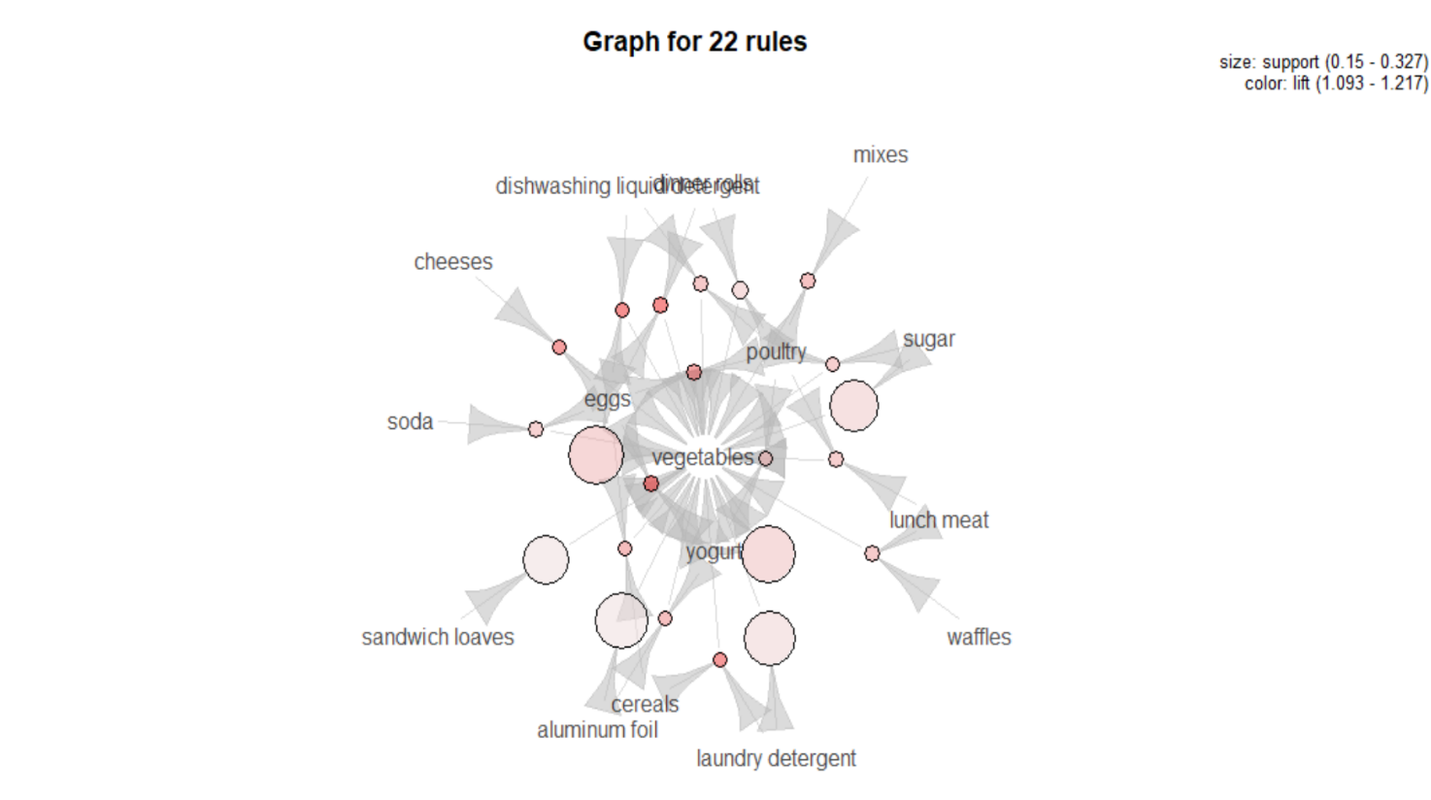

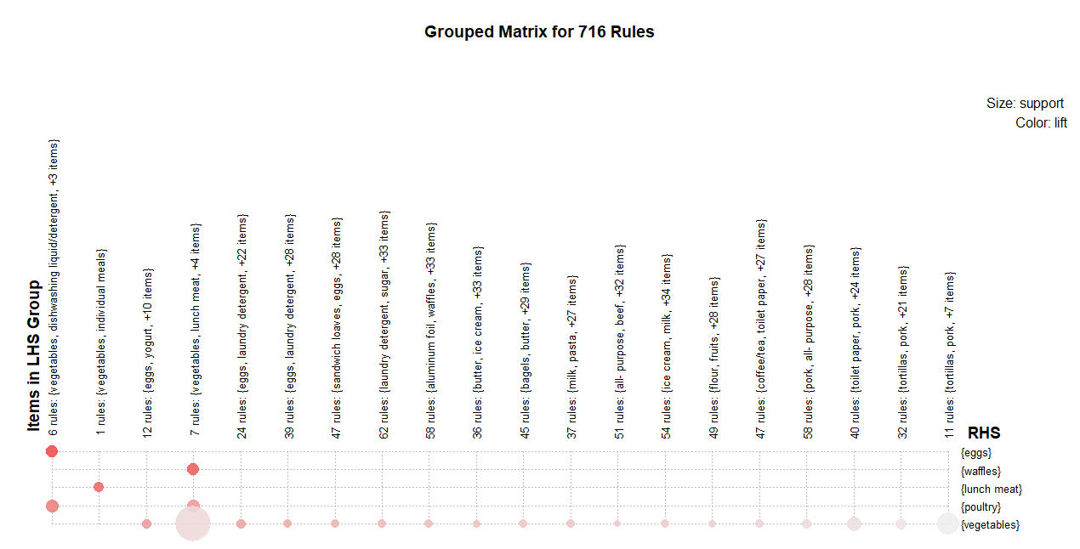

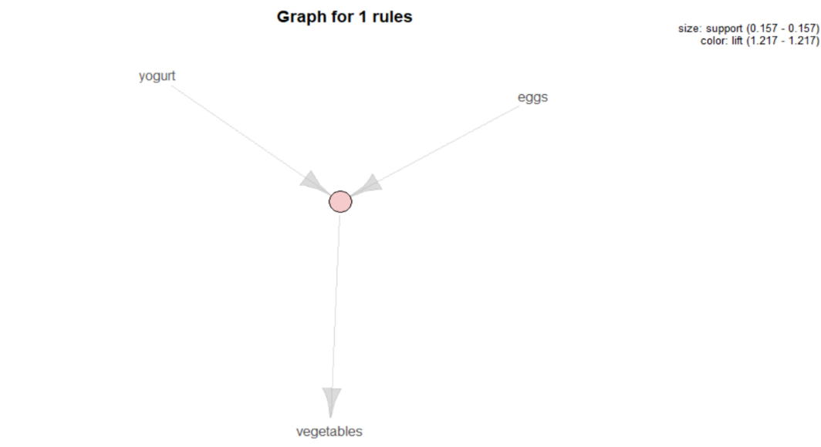

Here we have a graph of one rule to understand better the concept.  
We have yogurt and eggs associated together by a small support of 0,15 or 15% and a lift of 1,27 which means that there is 1,27 times likely that will be purchased together.